

**US**

|  |  |  |  |
| --- | --- | --- | --- |
|  | **COMPANY PHONE**  +8613794994473  **COMPANY MOBILE**  413471554@qq.com |  | **COMPANY WEBSITE**  <https://dgshuiye.en.alibaba.com>  **COMPANY LOCATION**  Building2,No.9,Qiaotou Bridge New Road,  Qiaotou Town,Dongguan City,Guangdong Province,China |

**PRODUCT CATALOG**

H

Huiye's goal is to create higher value for customers,and we are willing to become your best supplier!

The company's tenet:"high-quality products,high-quality service,preferential prices,timely delivery".

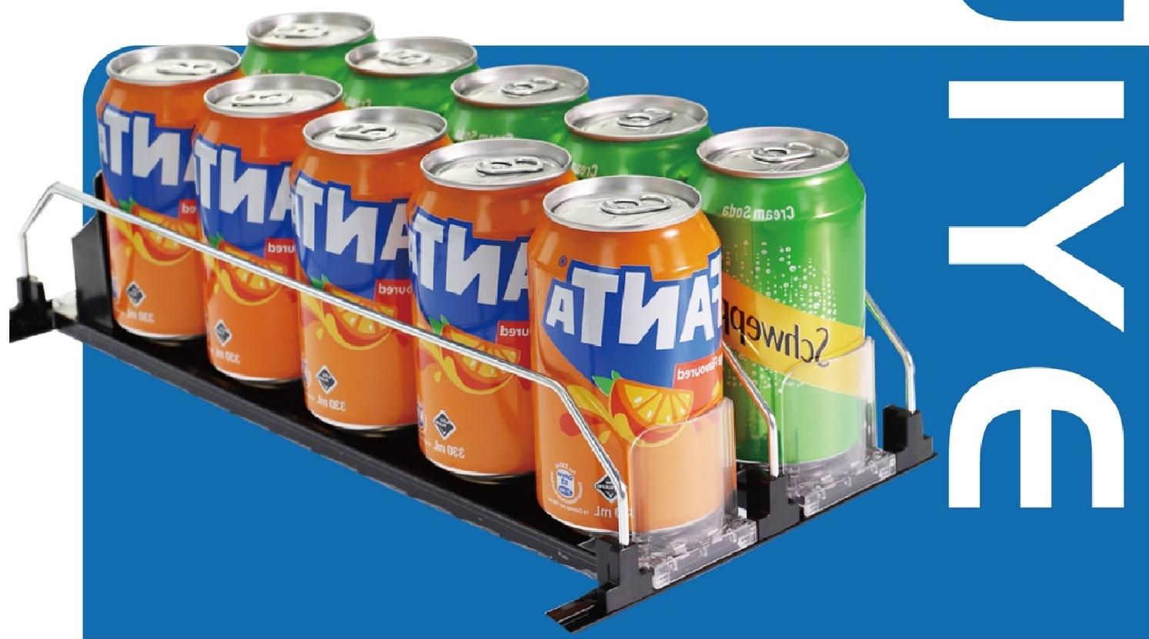



**ALL CATEGORIES**

See All Categories

|  |  |
| --- | --- |
| Double Spring Drink Pusher Single Spring Drink Pusher  Snus pusher **Cigarette pusher**  **Shelf pusher Food pusher** | Roller Ball Pusher  **Cigarette label box**  **Closet Shelf Organizer** |

*好⑥*

Magnet Shelf dividers

Shelf dividers

Manual Pusher Stand

**Magnetic Closet Shelf Organizer**

**Shelf dividers**

**Shelf Pusher**

**Manual Pusher Stand**

**Snapable divider**



**COMPANY**

**INTRODUCTION**

Dongguan HuiYe display products Co.,LTD.





Production machine



Patent certificate

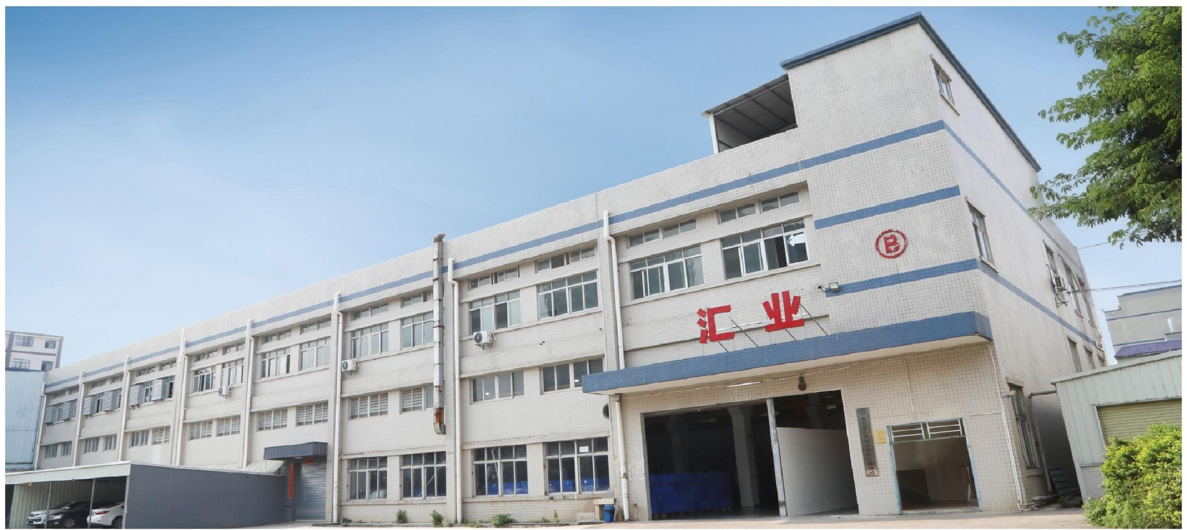

|  |  |
| --- | --- |
| **COOPERATIVE BRAND**  *华润万家* vanguard  巨 乐 9l 吊  **BiaoH**  **阿里巴巴**  Alibaba.com  **Walmart**  **Save money.Live better.**  **METRO**  ***麦法龍*** | **DONGGUAN HUIYE DISPLAY PRODUCTS CO.,LTD.**  Established in 2020,HUIYE is obtained over 13 patents for our products,After several years'hardworking, HUIYE has wontrust and happy cooperation from customersboth domestic and abroad.HUIYEis the orginal manufacturer of drinks pusherglide,in charge of the whole production process including tooling,plastic in- jection,springs,assembly,packaging,etc.  HUIYE aims to be the most efficient show shelfmaker in the world,and would like to be yourbest supplier for your!HUIYE promises that "Qualified productExcellent service Competitive price and Promptdelivery". |

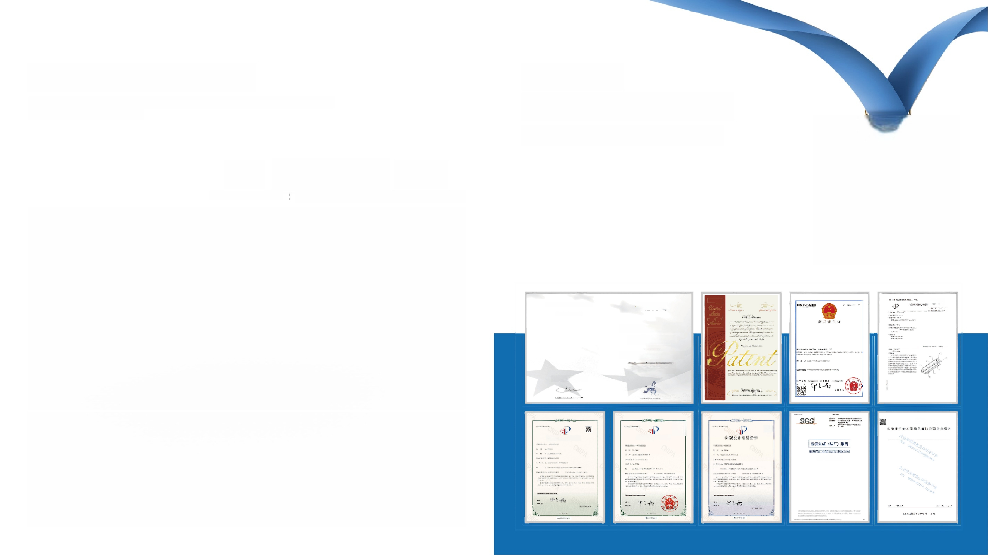**FACTORY DISPLAY**

Has a complete production line,including product mold development injection molding, spring,assembly,packaging,etc



**Production machine** production quantity !Quantity of foreign trade

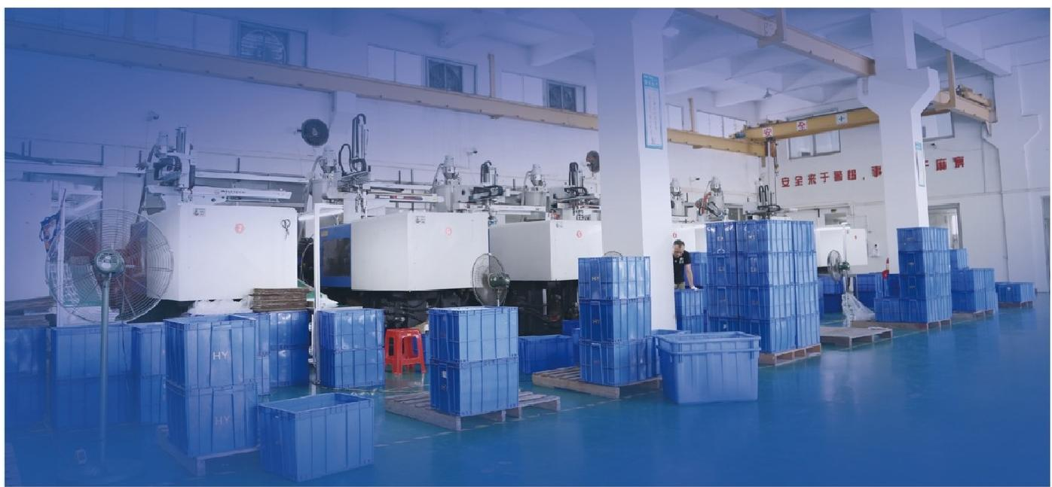

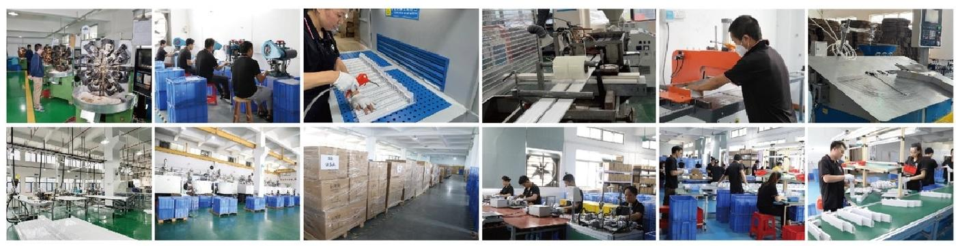

**PATENT**

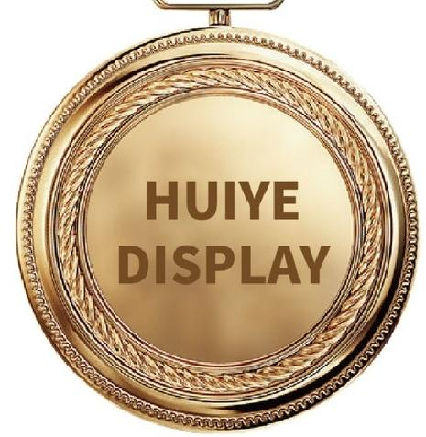**CERTIFICATIONS**

Reliable Product Quality and Safety



*Registered/Eingetragen 08/09/2023*

**P EUIPO**

No 015033559-0001

RATION

CFRTr E

^MTEF

**汇页**

UANNFFOR



Thc Exeurteorecor/Dor

**Q/HYZS**

器

Q/H2001-2023

**实用新型专利证书**

**实用新型专利证书**

**推烟器**

响 9 : 5ZONT230122913



**COMPOSITION OF THE PRODUCT**

Learn more

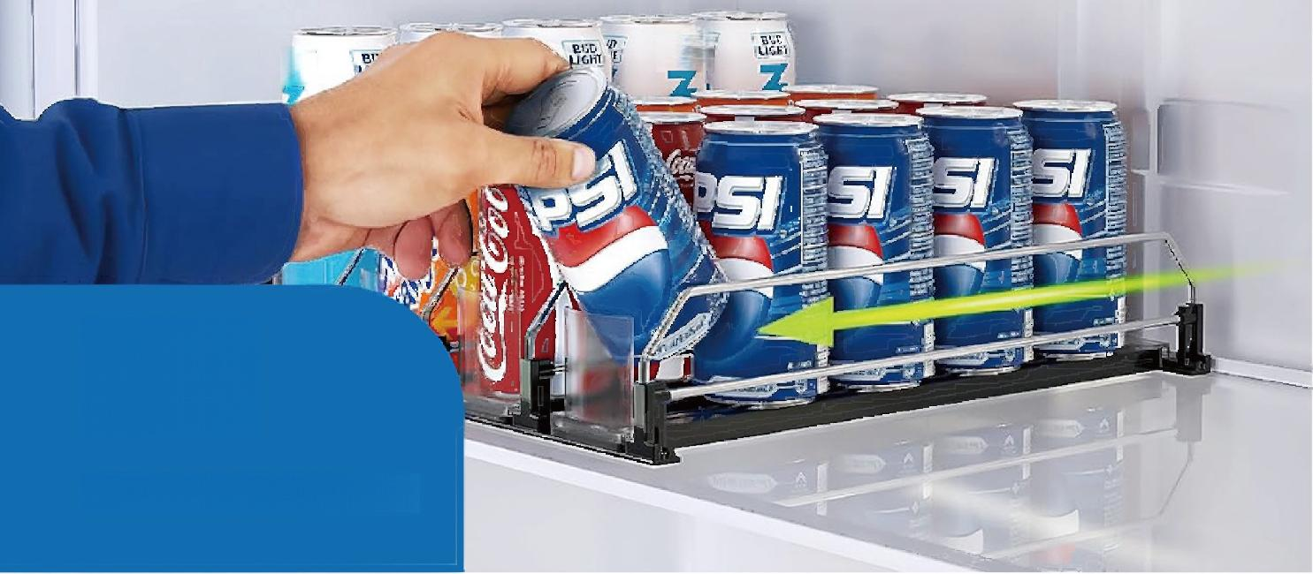

**03**

**DRINK ORGANIZER**

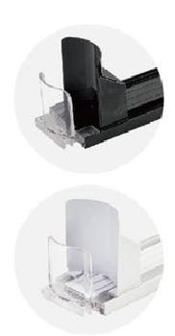

**Material:** PS/PC+ABS+SUS304

**Color:**White/black

**Product application:**Automatic advancement of beverage arrangement on shelves or refrigerators

Widely Use:The Drink organizer for refrigerator features an integrated spring pusher design that

automatically and smoothly slides your drink forward.This ensures that your drink is always prominently displayed for easy access.It's suitable for various beverage types and environments.

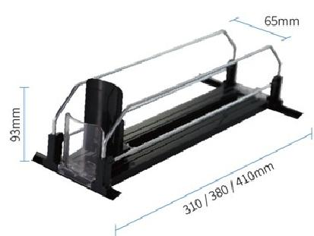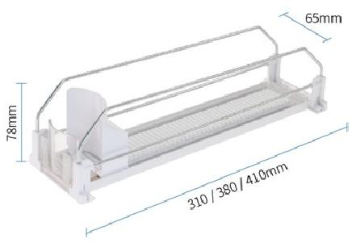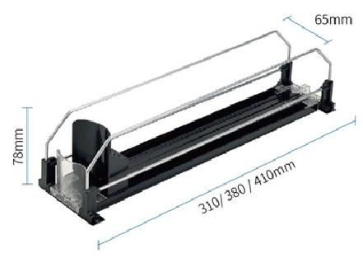



Roller Ball Pusher

Double SpringDrinkPusher



Single Spring Drink Pusher

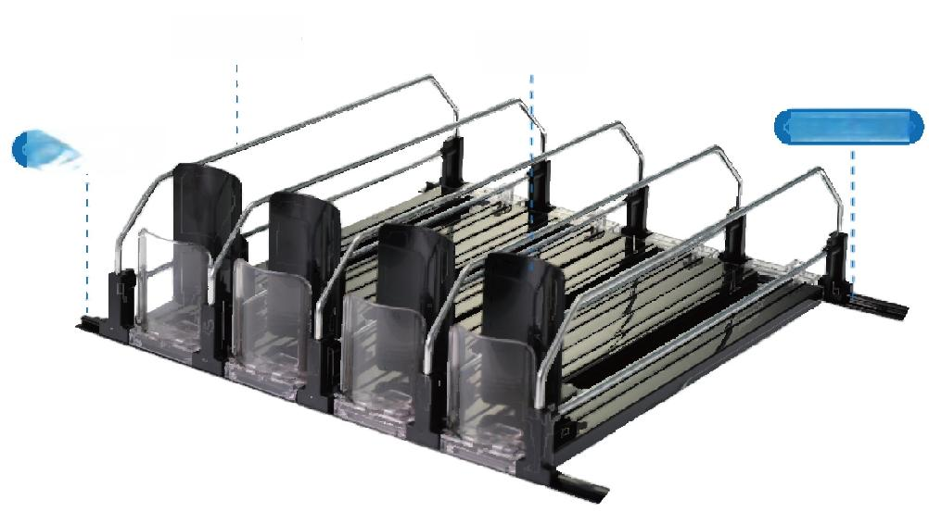

Divider Pusher

Fixing bar

Fixing bar

**PURCHASE OPTION**

The following accessories can be choose and customized freely

|  |  |  |  |  |
| --- | --- | --- | --- | --- |
|  | **STYLE** | Single Spring Drink Pusher | Double Spring Drink Pusher | Roller Ball Pusher |
|  | **COLOR** | White | Black | **Customizable** |
|  | **DIVIDER** | One bar divider Double bars divider Transparent baffle | | |
|  | **LENGTH** | 310mm 380mm 410mm Customizable | | |

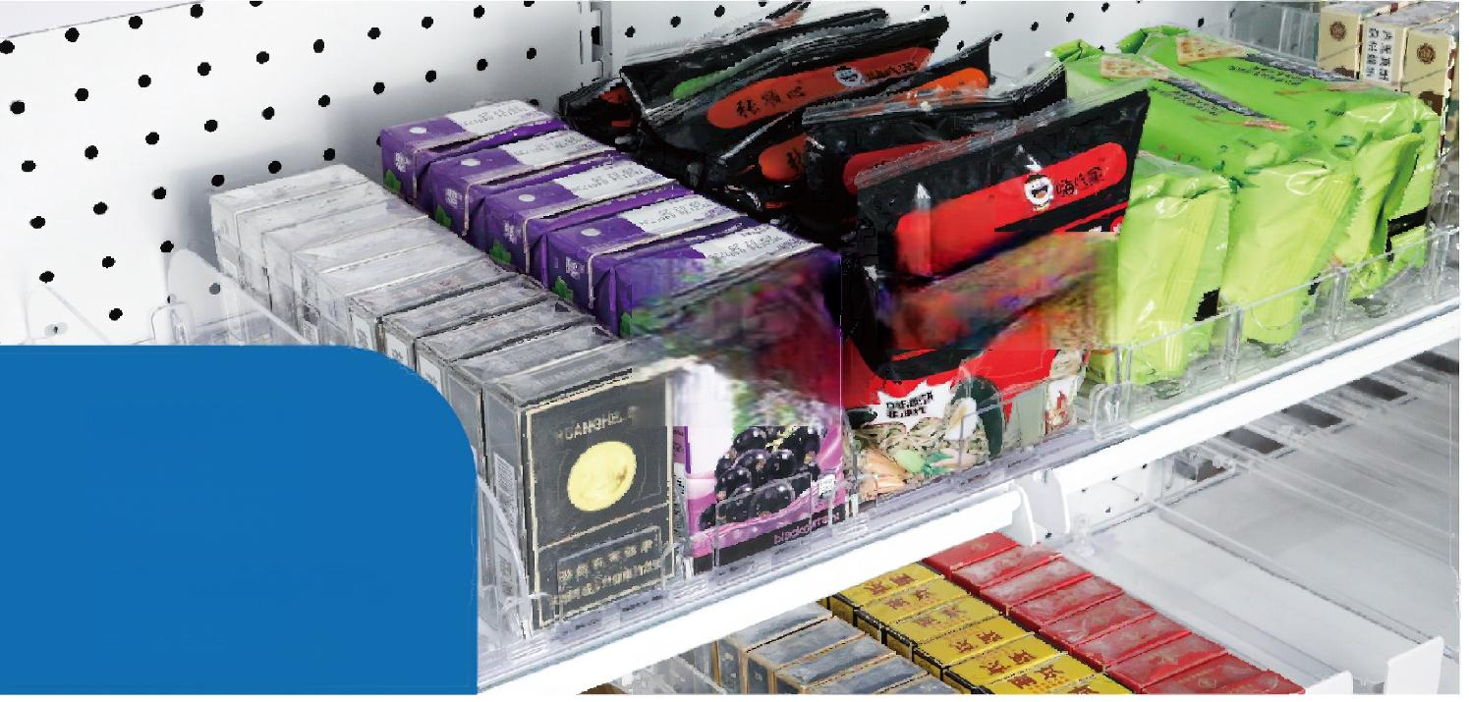

*顺* *心*

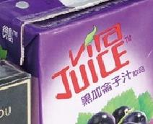 莱麦度

**04**

**SHELF PUSHER**

Adjustable width

**PURCHASE OPTION**

The following accessories can be choose and customized freely

|  |  |  |
| --- | --- | --- |
| COLOR  **FIXING BAR**  **BAFFLE**  LENGTH | Transparent  White  Fixing bar  _  Double bars dividerbars divider    200/250/280/300/310/350/380mm | Customizable  Fixing bar    Transparent baffle  Customizable |

**Material:** ABS/PET/POM+PVC+SUS304 **Spring strength:**3N/4N/5N/6N/7N/Customizable

**Color:** Transparent/white/customizable **Adhesive customization:**Can bepasted 3M tape/no traceglue/sponge glue

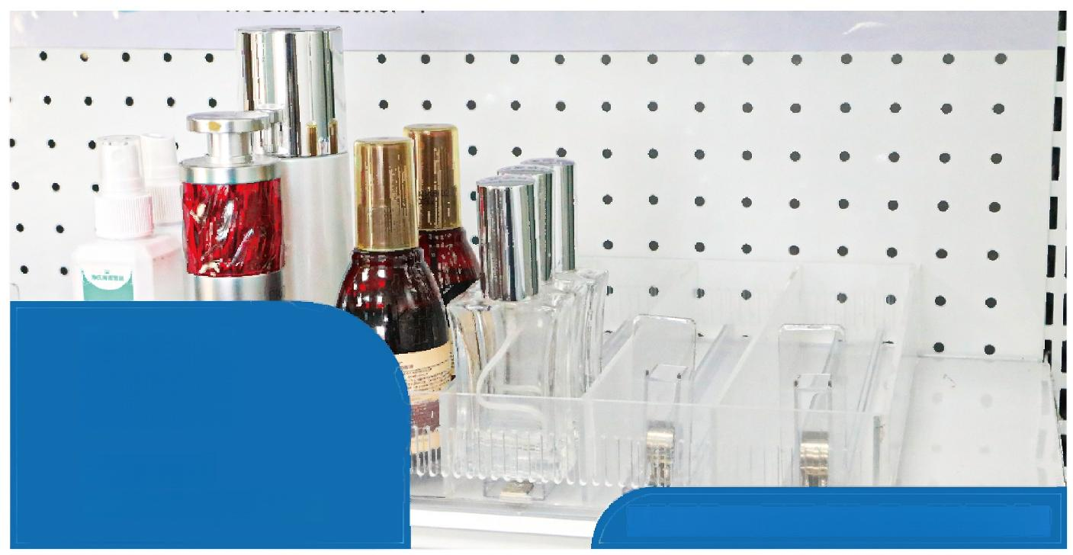

**05**

**PUSHER**

Use with display stand Suitable for acrylic/plastic/cardboard shelf display

**Spring strength:**3N/4N/5N/6N/7N/Customizable

**Material:** ABS/PET/POM+PVC+SUS304

**Color:T**ransparent/white/customizable

**Adhesive customization:**Can be pasted 3M tape/no trace glue/sponge glue

72mm 72mm

72mm

72mm

72mm

72mm

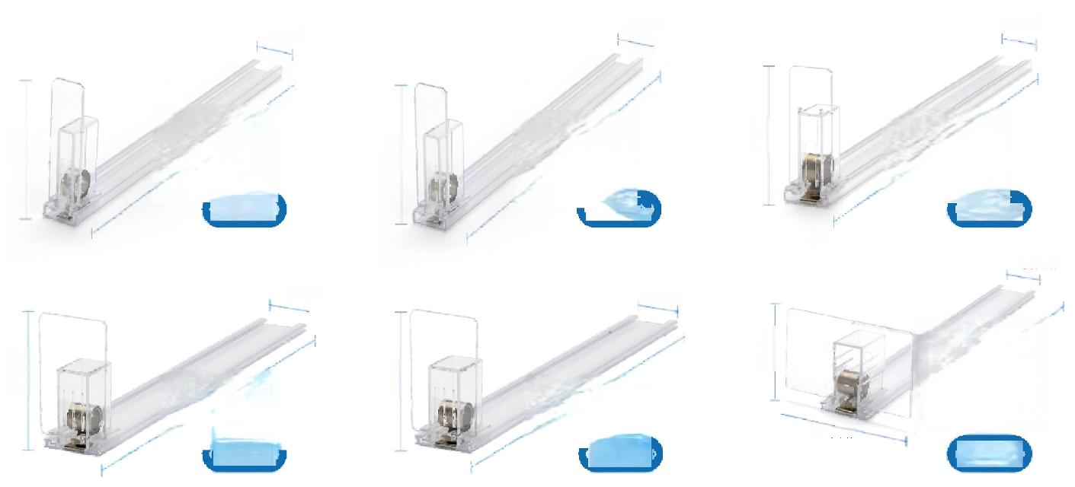

18mm

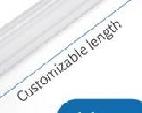

Iolm

36mm

36mm

90mm

36mm

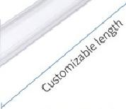

25mm

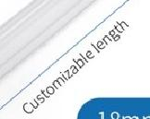

90mm

14mm

25mm

**34mm**

14mm

34mm

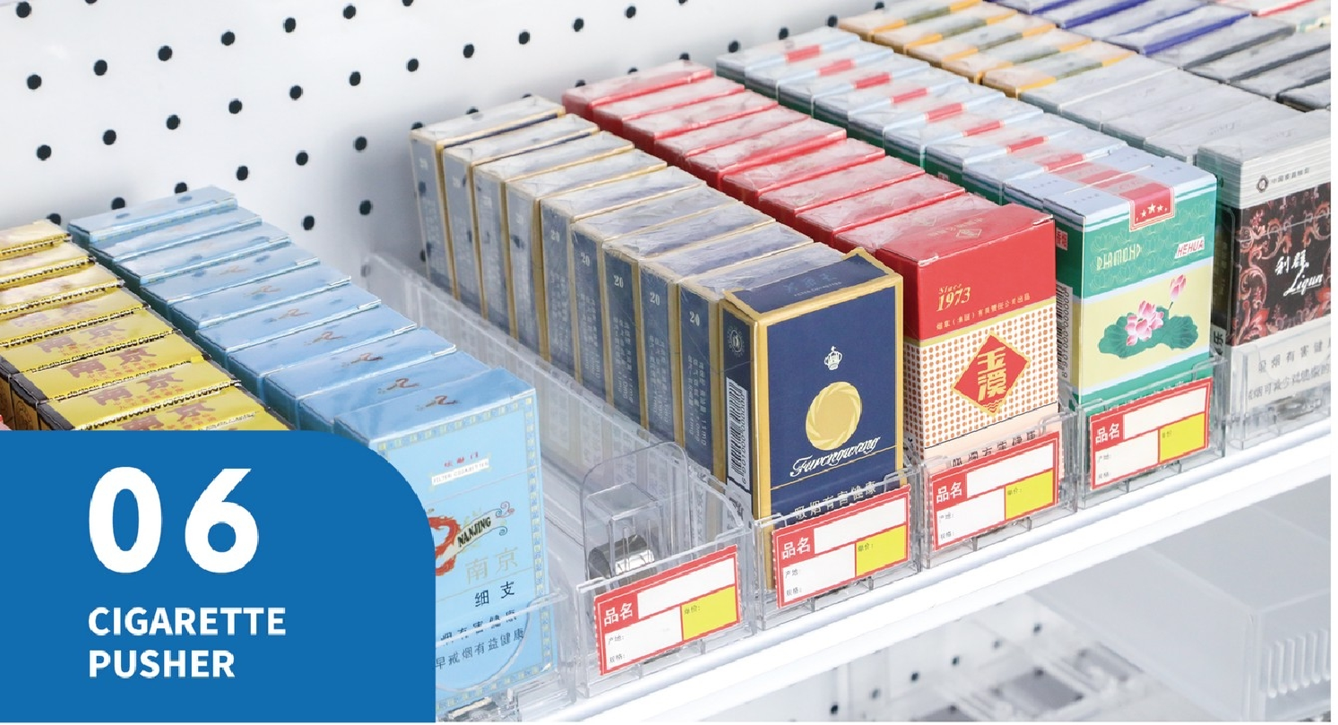

**UNILATERAL CIGARETTE**

**Material:** PS/PC+ABS+SUS304

**Color:** Transparent

**PUSHER PURCHASE OPTION**

The following accessories can be choose and customized freely.

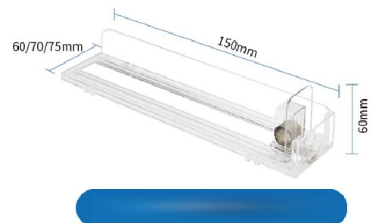

Unilateral cigarette pusher

Wide strips can be added to adjust the width according to requirements. and different sizes of cigarettes can be placed.

**Unilateral digarettepushe**r

Widening pusher

Bafle

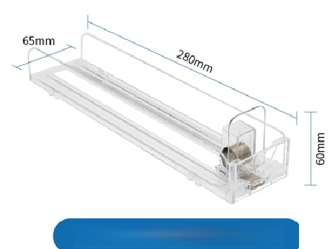

Bilateral cigarette pusher

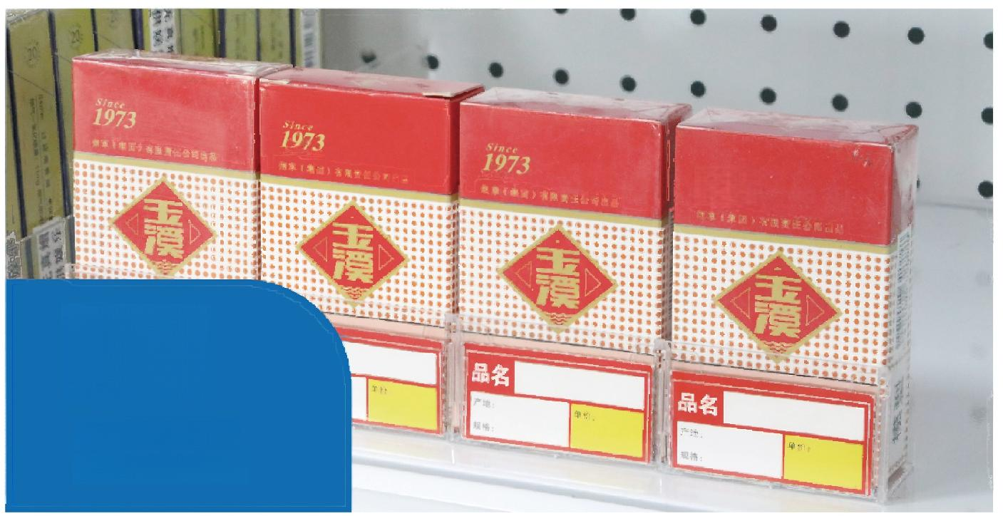

1973

**07**

**CIGARETTE**

**LABEL CASE**

**Material:** PS/PC

**Color:T** ransparent

|  |  |
| --- | --- |
| **Size:60mm*19mm*35mm** | **Size:60mm*29mm*35mm** |

|  |  |
| --- | --- |
| **08**  **DIVIDERS** | 膳食纤维+  黑加命子汁的品 |

Use with display stand

**Material:** ABS+SUS304+Plastic **Customizable:l**ength,height,color(small order can be customized)

**Color:T**ransparent/white/black

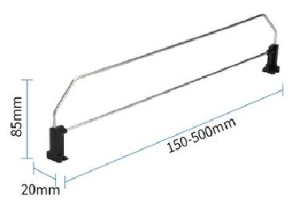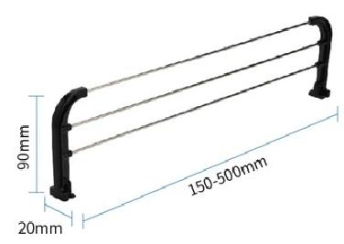

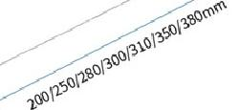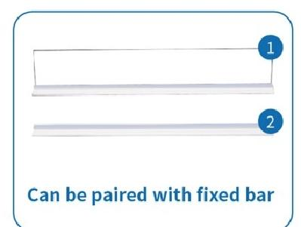

60mm

120mm



**One bar divider**



**Three bars divider**



**Double bars divider**

|  |  |  |
| --- | --- | --- |
| **20mm** |  | 25mm385mm485mm |

**20mm**



**Transparent baffle**



**Breakable Divider**

香葱

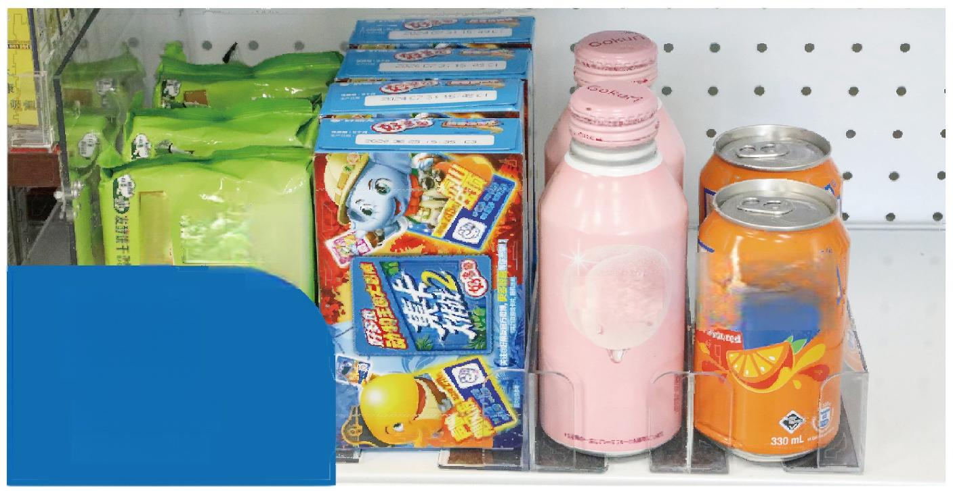SunTORY

梳

√ 易消化

过

**09**

Gokuri

*小ん力D* *一天*

ANT

**Peach**

**MAGNETIC DIVIDERS**

|  |  |  |
| --- | --- | --- |
| **Material:** ABS+SUS304+Plastic  50mm 50mm  **Color:** Transparent  20  40mm  **Large-left divider**  52  *35mm*  **Small-Left divider** | **Customizable:** length,height,color(small order can be customized)  **Adhesive customization:**Magnetic,3m glue,seamless glue,sponge glue | |
| 50mm  *20m*  *40mm*  **Large-middle divider** | 5omm  *20m*  *40mm*  **Large-right divider** |
| 50mm  152mm  152mm  *35mm*  35mm  Small-middle divider  Small-right divider | |

|  |  |
| --- | --- |
| 萨斯烧烤味 exas Grilled BBQ Flavor  **10**  **DIVIDERS**  9  一 | 八  培烤马铃薯蜜化食品 |

|  |  |
| --- | --- |
| **Magnetic Closet Shelf organizer** | **Material:** PVC+Magnet  **Color:** Transparent  **Adhesive customization:** Magnetic,3m glue,seamless glue,sponge glue |

205mm

**Material:** PS/PC+Magnet

**Color:** Transparent

**Adhesive customization:**Magnetic,3m glue,seamless glue,sponge glue

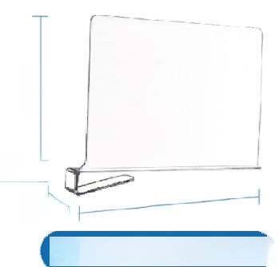

32mm

30mm

**Closet**

*300mm*

**Shelf Organizer**

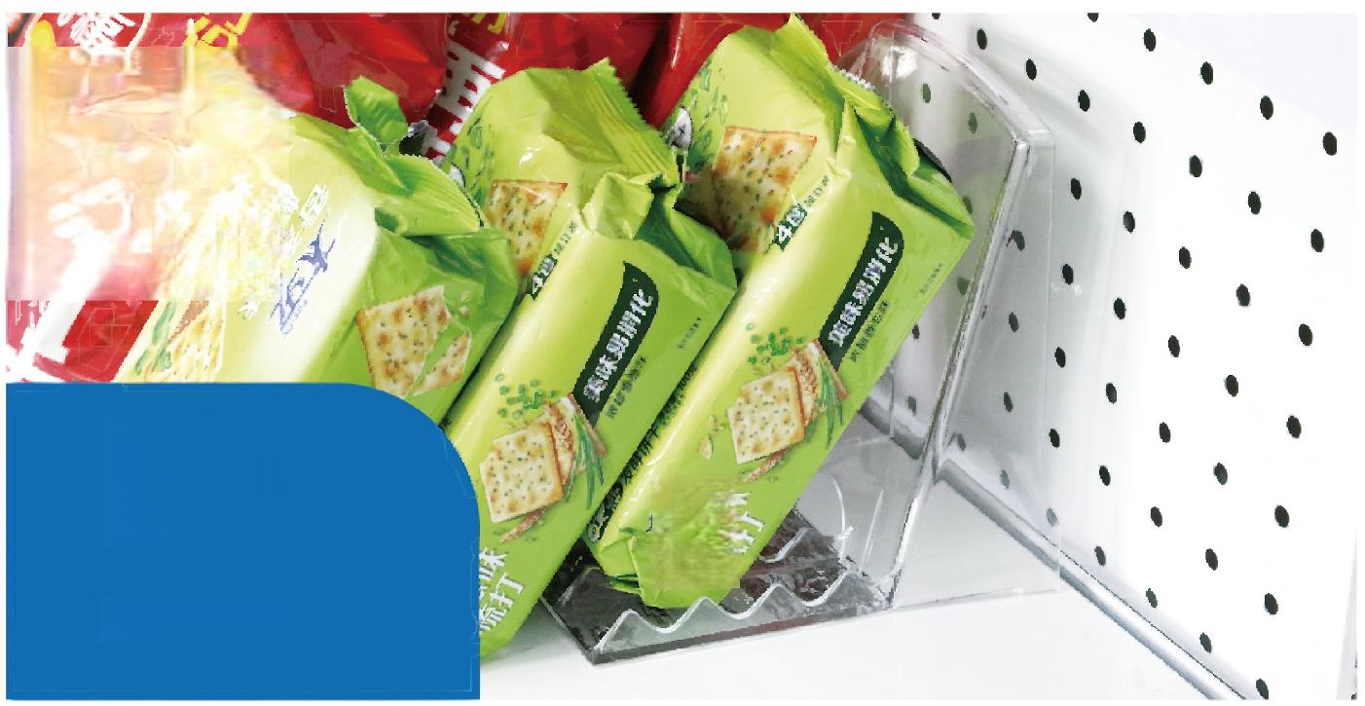

**12**

**DIVIDERS**

**Material:** PS/PC **Can be matched with products:**Shelf divider

**Color:**Transparent **Adhesive customization:** Magnetic,3m glue,seamless glue,sponge glue

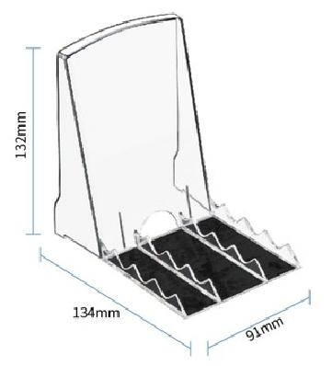



**Small-magneticizer**

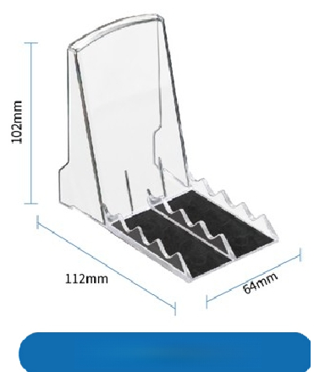

**Small-magneticizer**

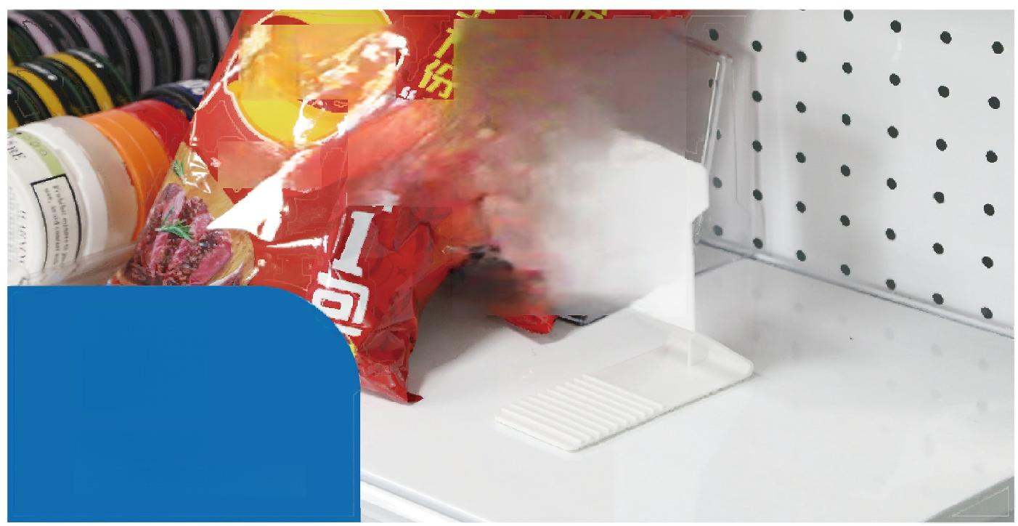*kys*

*得克萨斯烤味*

**11**

**PUSHER**

Use with display stand

|  |  |
| --- | --- |
| 110mm  **Magnetic Closet Shelf organizer**  65mm  0sn  **Closet ShelfOrganizer** | **Material:** ABS+Magnet  **Color:** White  **Adhesive customization:** Magnetic,3m glue,seamless glue,sponge glue  **Material:** PS/PC  **Color:** Transparent  **Combination products:can be used with partition boards** |

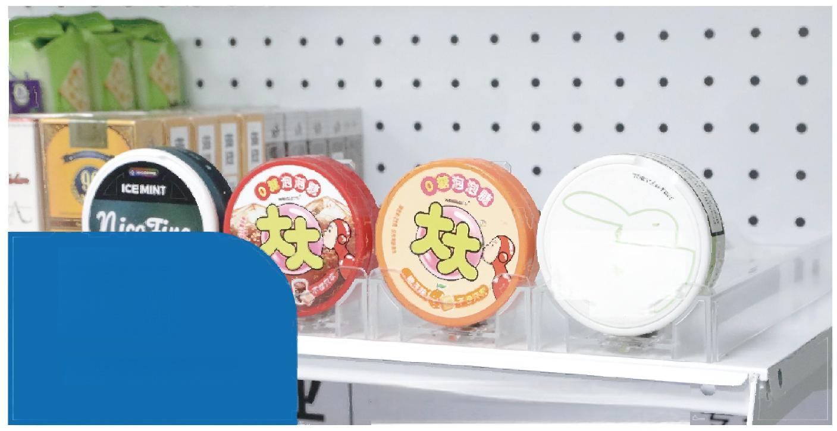HCRE

**12**

COCONUT

**SNUS PUSHER**

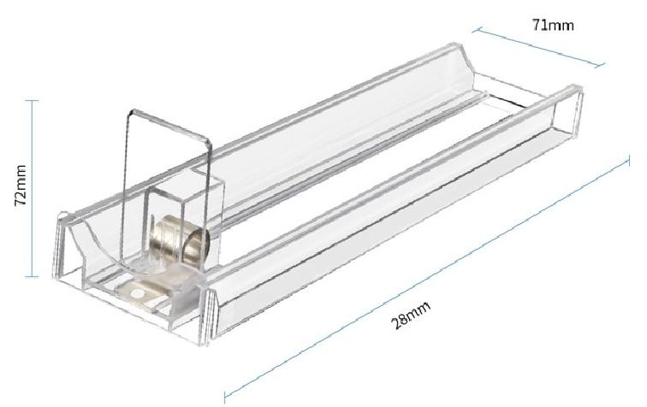



**Snus pusher**

**Material:** PS/PC+ABS+SUS304

**Color:** Transparent

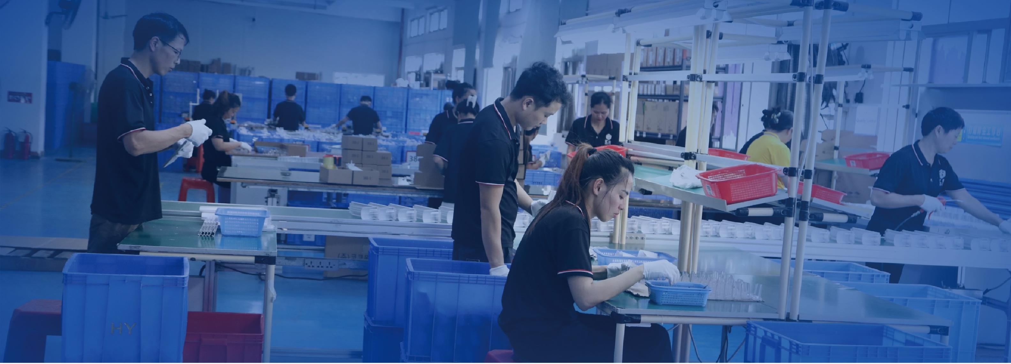

**THANKS FOR**

**WATCHING**



**WHATSAPP**

+44858622



**COMPANY ALIBABA CONTACT**

<https://dgshuiye.en.alibaba.com/contactinfo.html?spm=a2700.shop_cp.88.29.2e15850146rIAk>